**General Recommendations:**

1. Walk through with attendees how to get into the lab system, how to navigate and the features of the “lightning bolt” etc.
2. Inside the Vm you can change the screen resolution as you would on your personal pc. This will fill in the grey area.

**Lab 1**

**Lab 2**

**Lab 3**

**Lab 4**

1. Had to restart DC.
2. Step 16-17 – Something is missing.  They forgot the step to Create the pool on the Confirmation page.

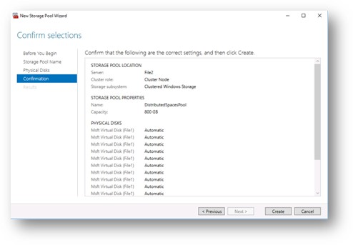

**Lab 5**

1. Was going great until it was time to launch the VMs in Step 9 of the “Deploy a new Virtual Machine” task (3rd task). The machines would not start.  “Host not responding”.

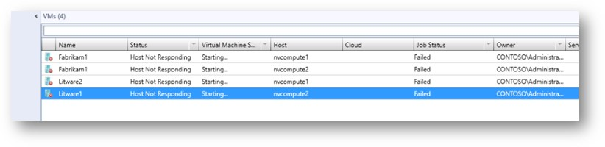

It wouldn’t be an issue if they weren’t required to be running for the last task “Test Hyper-V Network Virtualization”.  But they are. For “gits and shiggles” I tried restarting the two machines in the NVCluster, and lo-and-behold I was then able to start the VMs. The pings and the proof that the virtual networks were indeed isolated worked as expected.

**Lab 6**

1. Lab 6 didn’t come up with the new lab manual interface that I was expecting.  I’m wasn’t sure if that’s just my bad luck or a real error in how it’s configured, so I launched it twice.  Same result.  We may need to print a lab manual for that one, or just leave it out.

**Lab 7 -** Lab 7 appears to be similar to the first of the Azure Infrastructure event labs.

1. **Task 4 – Step 3** – There is no “101-simple-windows-vm” as the instructions say.  There is a “101-vm-simple-windows”, which is likely what they’re looking for.
2. **Task 8 – Step 9** – Same as in our Azure Infrastructure content, this step incorrectly tells you to create a “sizeOfEachDataDiskinGB” parameter, when the name really should be “sizeOfDiskInGB”.